**Exception:**

1. Occurred by programmers.
2. Recoverable.
3. Two Types.
   1. Compile Time Exception (Checked Exception).
   2. Run Time Exception (Unchecked Exception).

**Error:**

1. Occurred by lack of system resources.
2. Not Recoverable.
3. One Types.
   1. Run Time Exception (Unchecked Exception).

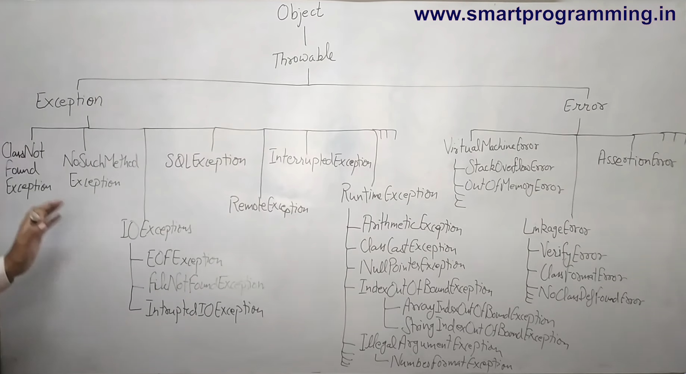

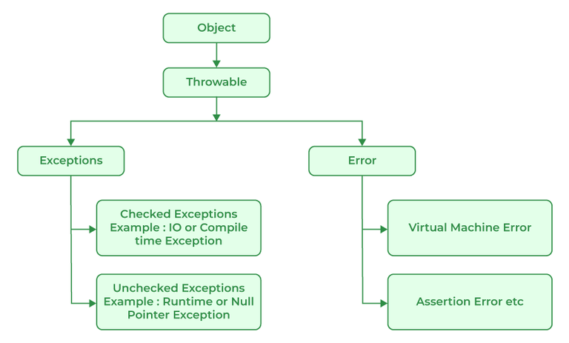

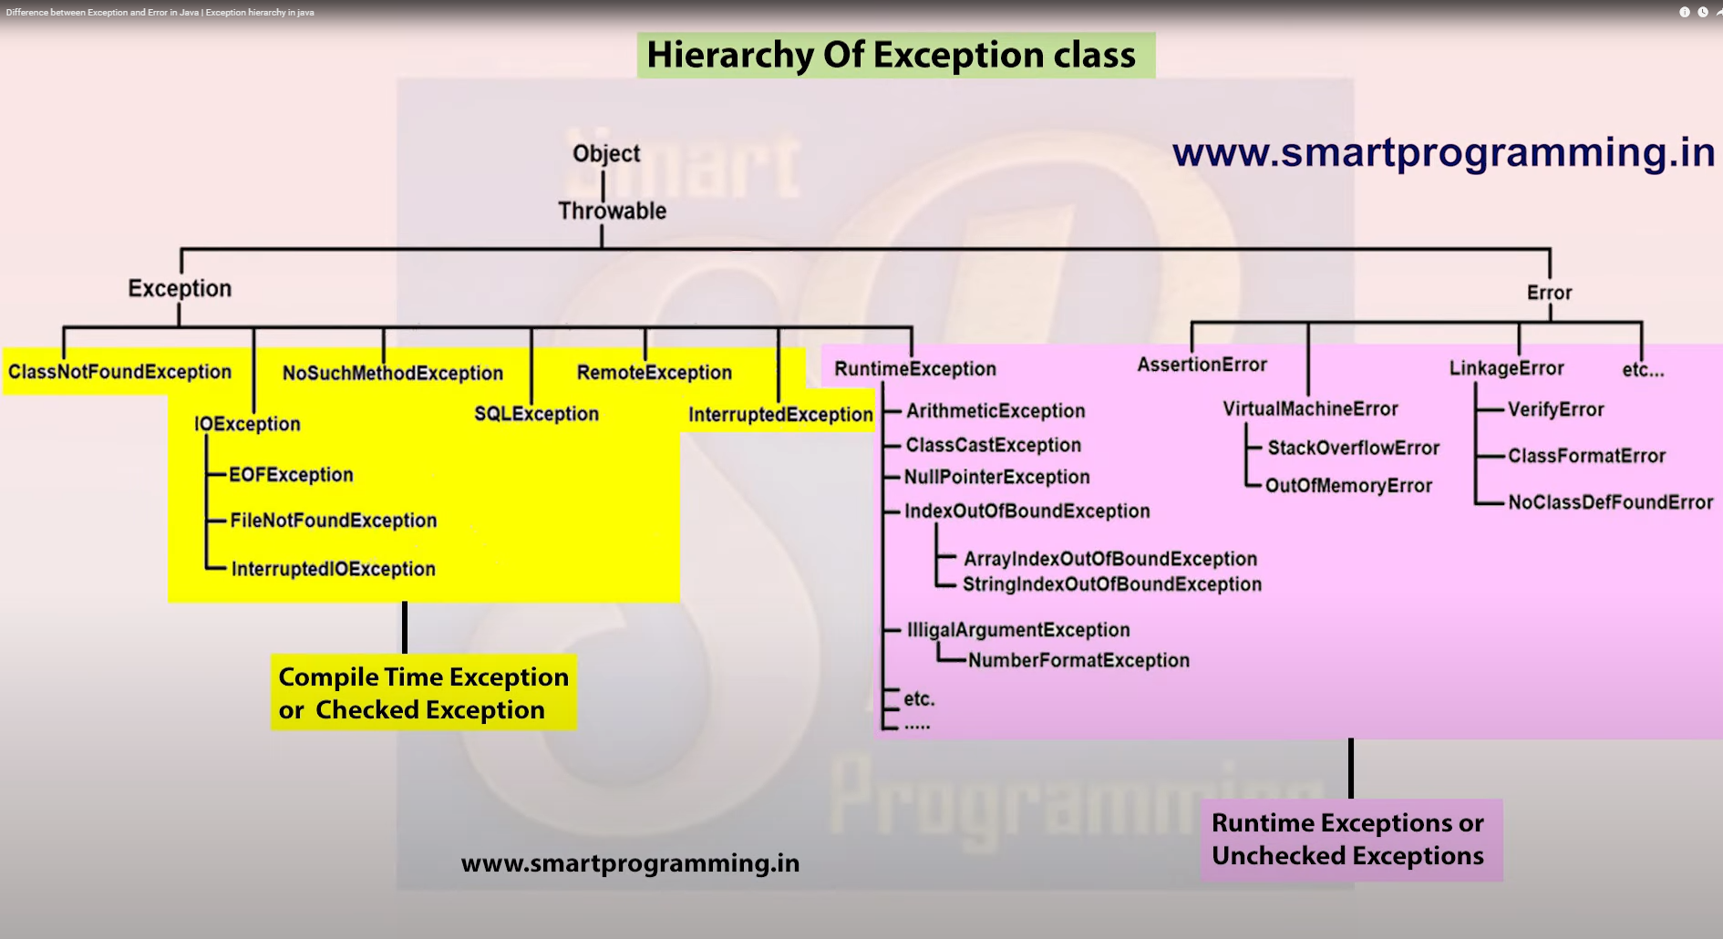

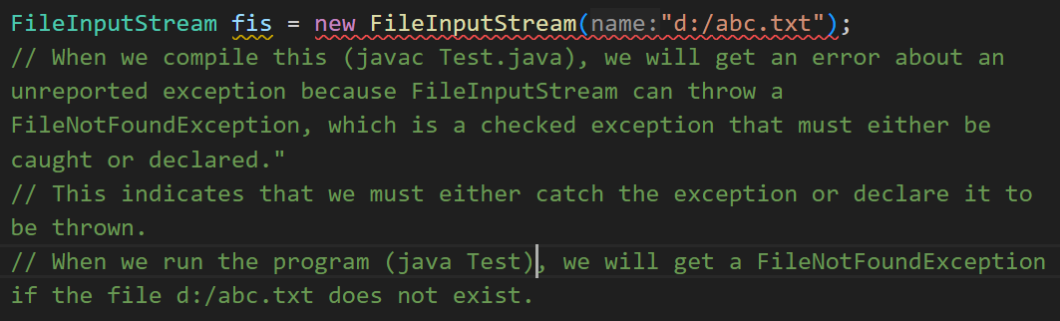

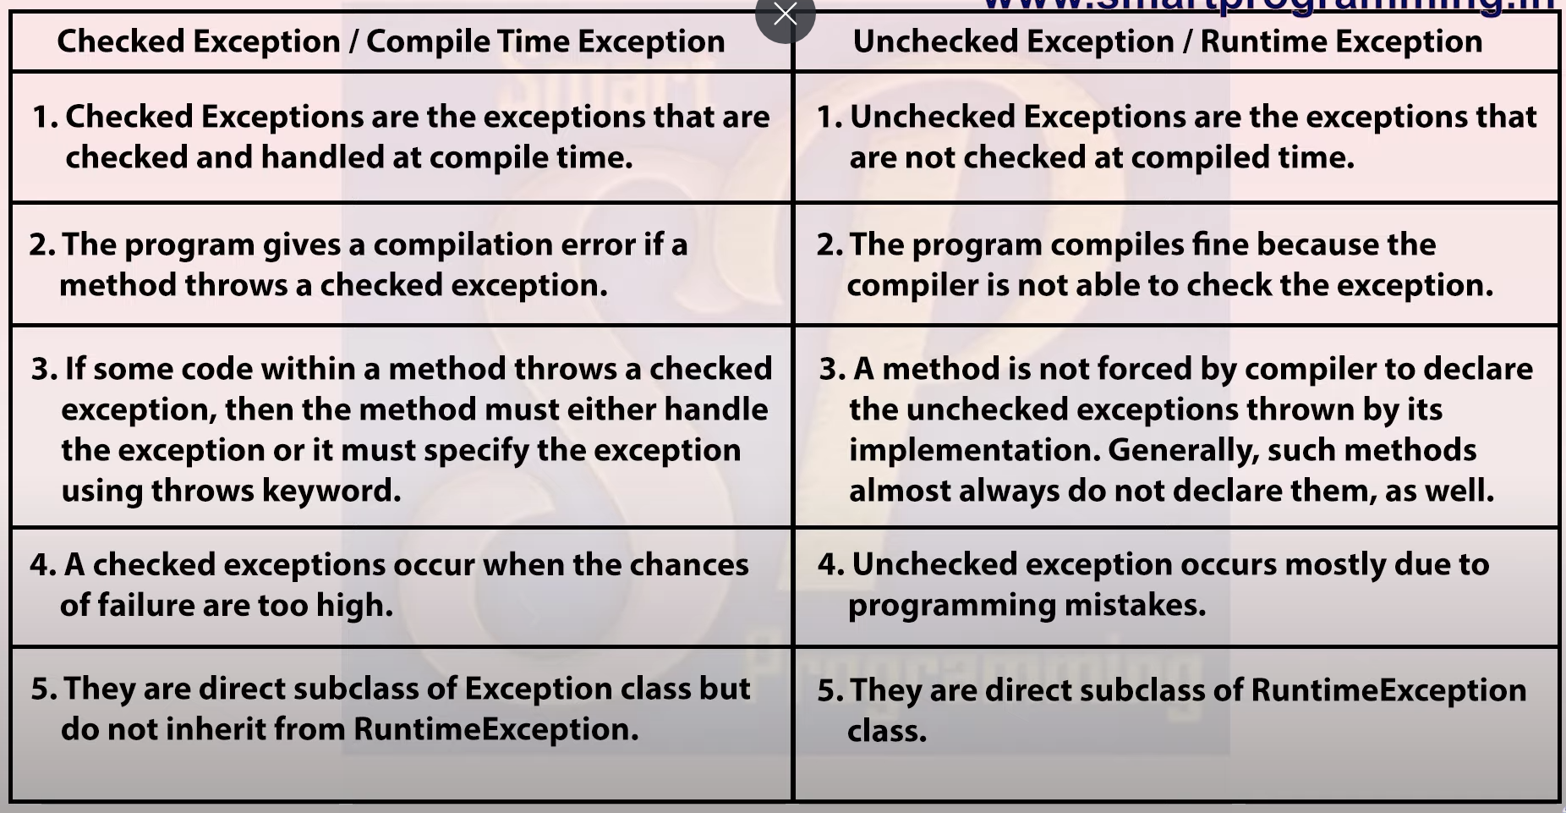





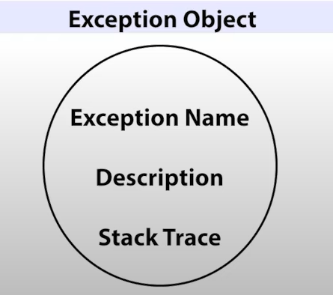

This is object (e) is created by the method in which the exception has occurred.

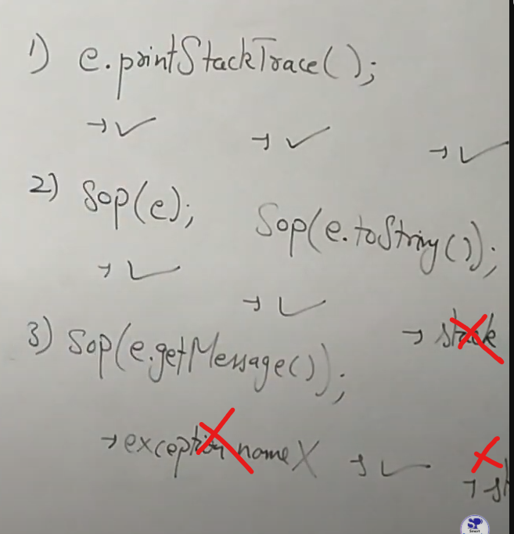



Try without block   
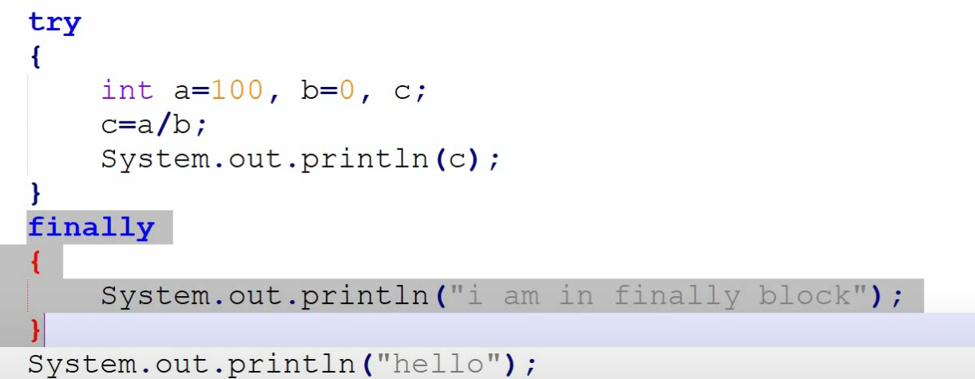

O/P:

I am in finally block

Exception: java.lang.ArithmeticException

(hello, will not be printed but finally block will be executed)

* If you write only try/catch/finally you will be getting error

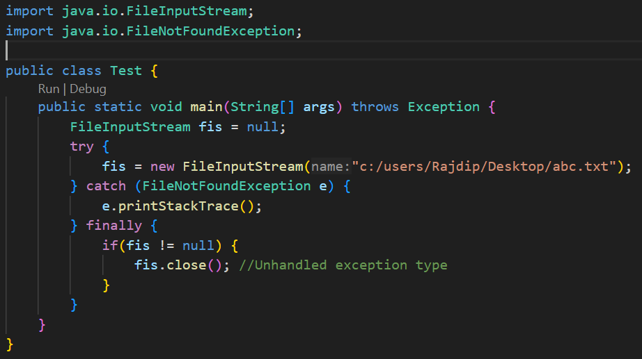

***



***



***









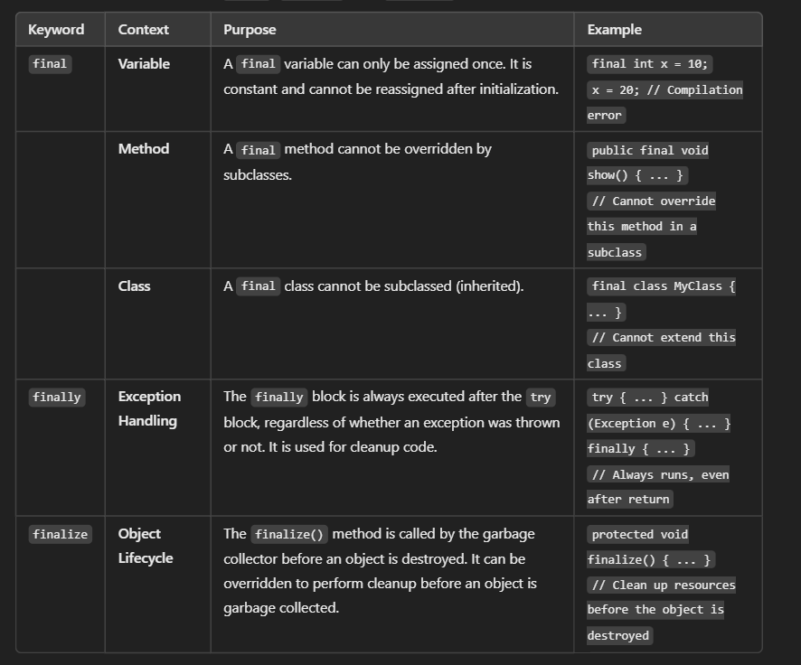

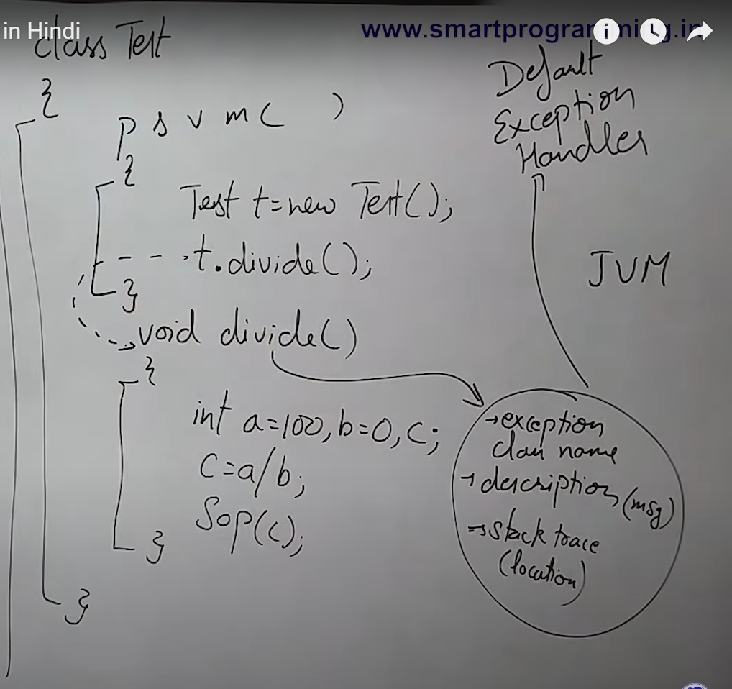

Main will be called by JVM, then it will create a test object and t.divide() will be called, in in the line 2 exception will be occurred now divide will create a object with details like exc. Name, description and stack trace (contains the location where this exception occurred). Now JVM will ask divide if that method handles that exception if no then

The method will be closed abnormally and now JVM will ask main and main will not also handling this exception so JVM will be terminating both. And the object will be passed to Default Exception Handler and it will be printed.

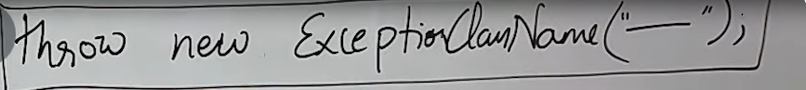 🡺 Responsible for creating exception object manually.

If there are any exception it will be passed to Default Exception Handler. Means it has no use in predefined exceptions handling.

After passing the exception object to DEH, DEH will print the message (via the object) and the method from which exception is received will be terminated, means here also the exception is not handled.

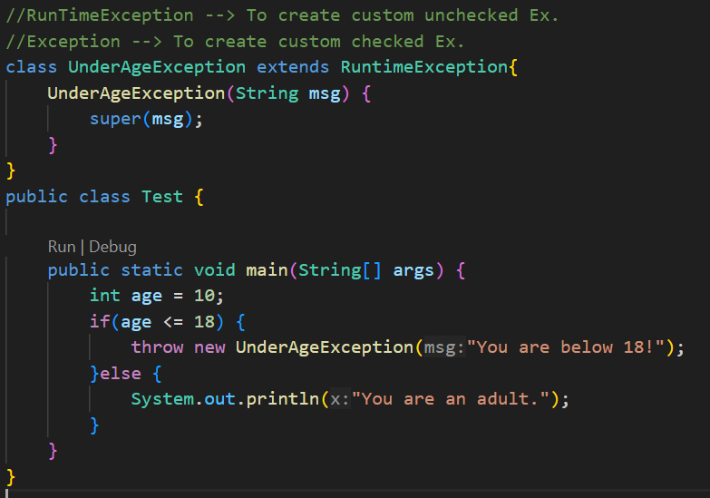

//To handle the exception use try catch

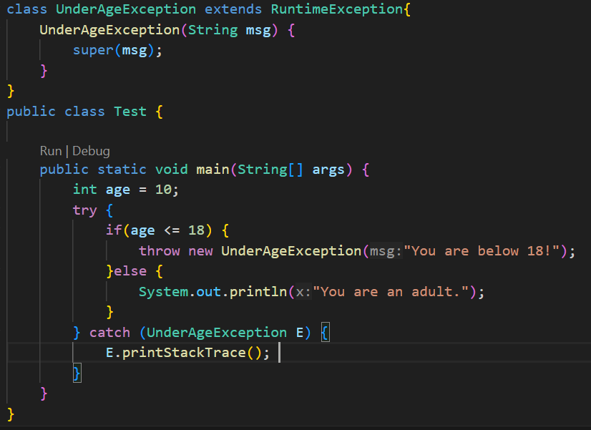

We cannot write any statement after throw keyword.



**throws is used for both checked and unchecked exceptions** but is required only for checked exceptions by the Java compiler. You can use it for unchecked exceptions, but it's not required. Because for uncheked exceptions if we don’t handle it and compile the code it will show unreported exceptions so if you add throws with the method and does not handels the exception then also the code will run.

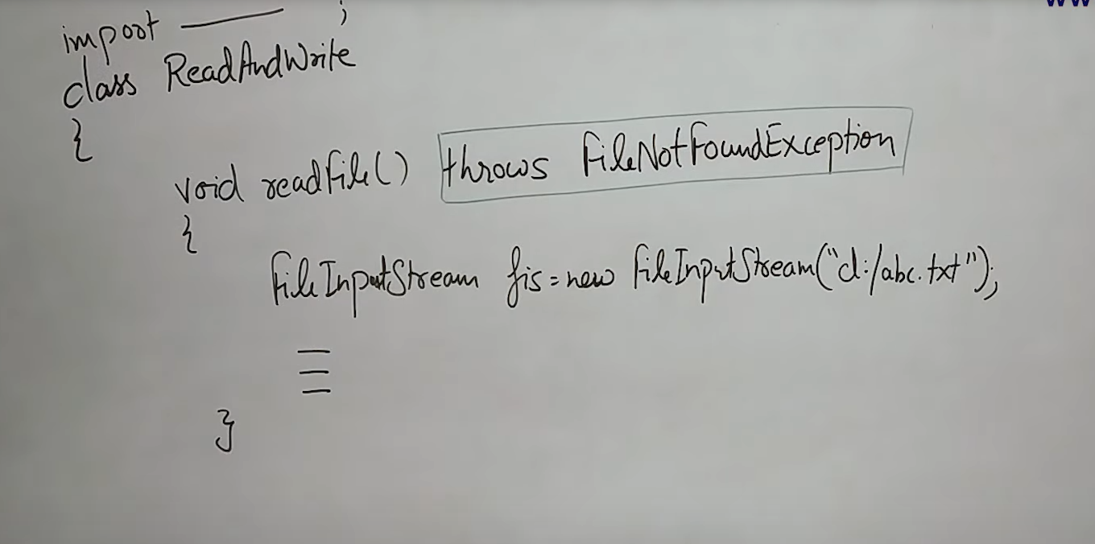

Its simply means that this method can throw exceptions who ever using this method should handle the exception (ex. Using try catch)

